CENTRAL NOVA AREA SERVICE COMMITTEE OF NARCOTICS ANONYMOUS
October 26, 2025
 | Attendance: Home Groups – GSRs, Alternates, & Representatives
 | Group | Representative | Present? | Vote?
1 | 90 in 90 | No Rep | No | No
2 | Amherst Hope | Jeremy M | No | No
3 | Beacon of Hope | Joanne | Yes | Yes
4 | Breaking Free | Craig M | No | No
5 | Clean and Strait | Kyle M | No | No
6 | Hope for Today | Leigh K/Tracy W | Yes | Yes
7 | I Can’t We Can | Bill H | No | Yes
8 | Just for Today | No Rep | No | No
9 | Last Chance | Brian M/Elizabeth | No | No
10 | Liberation | No Rep | No | No
11 | Living Clean | Cindy S | No | No
12 | Love Life | Ryan M | No | Yes
13 | NA Lengths | Lindsay M | Yes | Yes
14 | Nature of Recovery | Darrell P | Yes | Yes
15 | New Vision | Em D | Yes | Yes
16 | Nothing to Fear | No Rep | No | No
17 | Orchard Valley | Jonah W | No | No
18 | Phoenix Group (Sydney) | Kathleen M | Yes | Yes
19 | Phoenix Group (Valley) | Willy W | No | No
20 | Pride in Our Recovery | Patty W Rep | Yes | Yes
21 | Progress Not Perfection | Karen S | No | No
22 | Serenity Seekers | Joe B | Yes | Yes
23 | Sharing the Message | Maryann | No | No
24 | Shelter from the Storm | Chad/Mariam | No | No
25 | Starting Point | Robert | No | No
26 | Strength in Numbers | Darrell A | No | No
27 | Survivors | Scott/Tyler | No | Yes
28 | Taking Care of Business | JB | No | No
29 | We Do Recover | Ray K | Yes | Yes
30 | You Have a Choice Today | Chrissy | Yes | Yes
31 | You’re Not Alone | Ernie C | No | No

Area Service Committee Executive
Chair | Vadim M | Present
Vice Chair | Vacant | Vacant
Secretary | JuleeAnn A | Present
Alternate Secretary | Vacant | Vacant
Treasurer | Jennifer M | Present
Alternate Treasurer | Vacant | Vacant
RCM | Vacant | Vacant
Alternate RCM | Vacant | Vacant

Area Subcommittees
Activities Committee Chair | Vacant | Vacant
Archives Committee Chair | Dave B | Present
Literature Committee Chair | Dolores F | Present
PR Committee Chair | Aubrey L | Present

CNA website: www.centralnovaarea.ca CNA e-mail address: centralnovaarea@gmail.com
The meeting opened at 1:35pm with the readings: 12 Traditions, 12 Concepts, A Vision for NA Service, and Service Prayer. September minutes
Attendance was taken with 10 groups present today out of 13 voting groups = quorum. 3 executive members are present. Every group present has a vote today which means we can make decisions today.
Any Observers: Clay, Sherry, Noelle, Paula, Nelson, Steve
New Groups to be seated: Noelle, North Sydney, Monday nights, 7:30pm “Hope not Dope”. Literature has meeting info to add to meeting list. Secretary gave Noelle a hardcopy GSR Orientation kit

GROUP REPORTS:
90 & 90
GSR: Alt. GSR:

Amherst Hope
GSR: Jeremy

Beacon of Hope
GSR: Joanne N Alt. GSR:

Breaking Free
GSR: Alt. GSR:
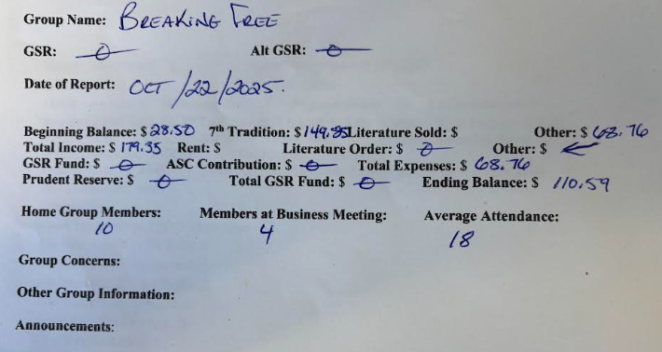

Clean and Strait
GSR: Kyle D Alt GSR: Thomas W

Hope for Today
GSR: Leigh K Alt. GSR: Tracy W
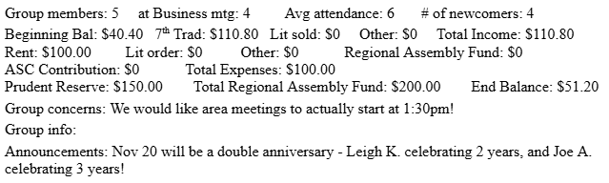

I Can’t We Can
GSR: Bill H ALT GSR:
Hello Area, All is good with I Can’t We Can. We had 5/5 home group members at the business meeting. Our average attendance is 15 – 18. All bills are paid. We noted the following: Yes – Vadim M, Chair;
Yes – Leigh K, Vice Chair; Yes – Dave B, Archives Committee Chair; Yes – Aubrey L, PR Chair. No waving clean time. No support for election. YIS, Bill H

Just for Today
GSR: Kristen C Alt. GSR

Last Chance
GSR: Joey B Alt GSR:

Liberation
GSR: Alt GSR:

Living Clean
GSR: Alt GSR:

Love Life
GSR: John A Alt. GSR: Brie Y

NA Lengths
GSR: Natasha Alt GSR: Lindsay
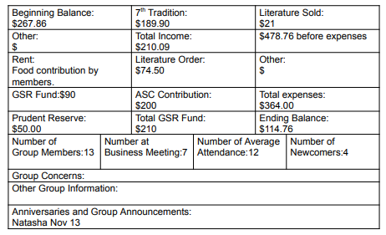

Nature of Recovery
GSR: Darrell P Alt GSR:

New Vision
GSR: Em D Alt GSR:
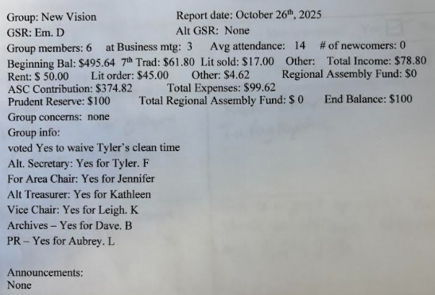

Nothing to Fear
GSR: Ashley Alt. GSR: Kary H

Orchard Valley
GSR: Jonah W Alt GSR:

Phoenix Group (Sydney)
GSR: Kathleen M Alt GSR:
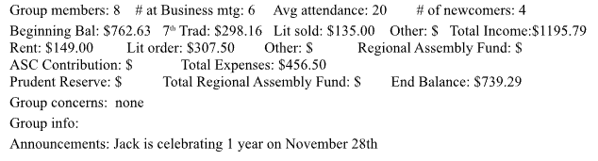

Phoenix Group (Valley)
GSR: Alt GSR: Willy W

Pride In Our Recovery
GSR: Alt GSR:
We had a business meeting with 4 members in attendance. We continue to be a zoom only meeting, and have been having members attend from across Canada, the USA and Europe. Our average attendance is 10.
We discussed the current nominations, and are prepared to vote on them today.
All of our financial obligations are met. We do not currently have a GSR. Group members will be submitting reports and representing the group in the absence of a GSR. Yours in service, Pride In Our Recovery Members

Progress Not Perfection
GSR: Karen S Alt GSR: Lisa H

Serenity Seekers
GSR: Joe B Alt GSR:
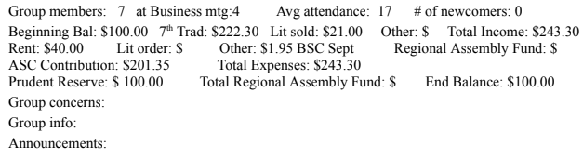

Sharing the Message
GSR: Alt GSR:
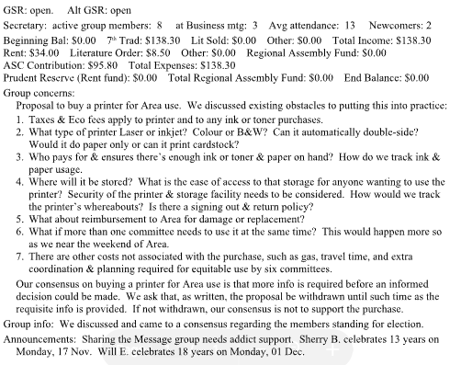

Shelter from the Storm
GSR: Em R Alt. GSR:
Email GSR orientation kit to Em

Starting Point
GSR: Steve T Alt GSR: None

Strength in Numbers
GSR: Alt GSR:

Survivors
GSR: Scott M Alt GSR: Jimmy H

Taking Care of Business
GSR: Alt GSR:

We Do Recover
GSR: Ray K Alt. GSR:
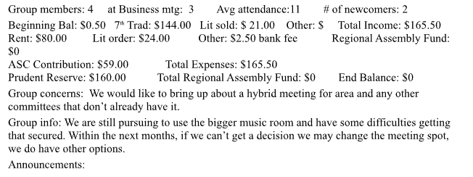

You Have a Choice Today
GSR: Chrissy B Alt GSR: Dominic

You’re Not Alone
GSR: Ernie C Alt GSR:

ACTIVITIES COMMITTEE: Vacant - Vadim read report

October Meeting
- October 25, 2025; 10:00 AM – 1:00 PM; Zoom
- Attendance: 7 (6 members, 1 new member)

Membership
- Currently have 12 members
- Changes
  - Judi M stepped down after the September meeting
  - Kathleen joined at the October meeting
  - John F elected to Secretary position during the September meeting
  - Dolores F stepped down from Vice Chair, Hospitality Coordinator, and Acting Chair positions
- Open Positions
- Chair
- Vice Chair
- Hospitality Coordinator
- Treasurer
- Assistant Registration Coordinator
- Assistant Hospitality Coordinator
- Issue
  - Key executive positions are open
  - Hampers the Committee’s ability to function effectively
  - Request that Area Service Committee appoint someone to the position of Chair, effective immediately and continuing until the position is filled

Summary of October Meeting
- Reports
  - No report from Chair and Vice Chair
  - Canteen Coordinator
    - Honour system used at the Fall into Recovery event did not work well
    - Will revert to staffing canteen for future events
  - Hospitality Coordinator
    - Chili, Caesar Salad, Apple Crisp and Pies
    - 65 people served
  - Registration Coordinator
    - 65 people registered
    - 10 hardship fund
  - Treasurer
    - See attached report
  - Program Coordinator
    - Event went very well
    - Speakers were amazing
    - Food was delicious
    - A big thank you to Activities members who helped put on the event
    - Future events: In out of the Cold and New Years Eve dance – more to be revealed
- Activities Committee Policy & Procedures Guidelines
  - Proposed amendments dependent on Convention Committee Policy & Procedures Guidelines
  - Request that Area Service Committee move forward with Convention Committee Policy & Procedures Guidelines
- In out of the Cold
  - Looking for contributions from groups and members who want to contribute their time to help put on the event
  - Contact Tyler F or Natasha N if you want to volunteer
  - A flyer will be out soon
- Games Day
  - Looking for one or more groups to host a games day
    - Weekend afternoon (preferred) or an evening through the week
    - Every second week
- Winter Activities
  - Looking for groups to host other activities throughout the winter, such as bowling night, skating, skiing, and tobogganing
  - Other ideas welcome
- Fall into Recovery and Spring into Recovery
  - Recommendation to increase registration fee to $20
  - The fee has been set at $15 for a long time and the cost of groceries and other supplies has increased significantly
  - Recommendation approved
- Next Meeting
  - Saturday, November 29, 2025
  - 10:00 AM
  - Zoom (849 0150 9248, password: cnana)

Respectfully submitted by Activities Committee Secretary
October 26, 2025

ACTIVITIES TREASURER REPORT:

Activities Treasurers Report
Oct 25, 2025

Item | Date | Check # | Amount
Opening Balance | Sept 27 |  | $4982.40
Bank Fee | Oct 1 | PAD | $8.75
Corn Boil income | Sept 28 | Etrans | 10.00
FIR – Hospitality | Oct 1 | 305 | 510.00
FIR – Programming | Oct 1 | 306 | 100.00
FIR – Rent | Oct 18 | 307 | 150.00
FIR – Cash income | Oct 18 | Cash | 560.00
FIR – Square income | Oct 18 | Etrans | 292.60
FIR – Square fees | Oct 18 | Square | 3.83
FIR – Lit – Clean time count down | Oct 18 | 308 | 56.00
Baseball Income | Sept | Etrans | 300.00
Baseball fees | Oct |  | 444.60
Closing Balance | Oct 25, 2025 |  | $4871.82

Amount before reserves | $4871.82
Convention Reserve | $3486.00
Activities Reserve | $1000.00
Total reserves | $4486.00
Amount after reserves | $385.82

The baseball cost is not final, it may decrease. At the September Activities meeting we agreed to increase our reserve to $1000.
Fall Into Recovery accounting is not final as we are waiting on Merchandise income.
As of today, we have a $385.82 surplus which we can pass on to Area, check #309.
Etrans = E transfer.
PAD = Preauthorized Debit.
Internal = Accounting done on the Spreadsheet

ARCHIVES COMMITTEE: Dave B, Chair
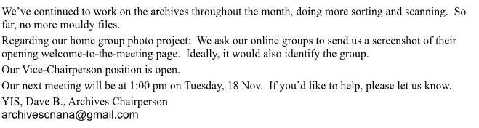

LITERATURE COMMITTEE: Dolores F, Chair
Opened at 9:30am with 2 of 3 voting members
No contribution this month. Making a NAWS order before prices go up
Price of Survival Kit will be the same
Updated price list will be available at November Area
We are submitting a proposal for clarity on absentee/applicability
Next meeting is November 23rd 9:30am on Zoom
This is my last Area as Literature Chair
Dolores F

Treasurer’s Report, Dolores Chair
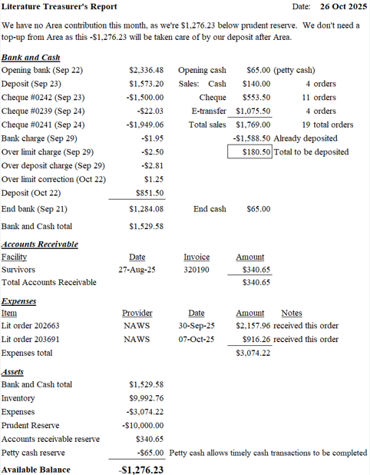

PUBLIC RELATIONS COMMITTEE: Aubrey L
Hello Family,
This report is prepared for today’s PR meeting.
The subcommittee met in-person today from 11:00-1:00 and we had a quorum of out of 13 voting members present.
Here are today’s highlights in point form:
● Withdrawal Management – Our panel leader for Withdrawl MAnagement 1 has stepped down and we are looking for interested members to step up for this position.
● Public Information – We have a National Substance abuse and addiction conference coming to town Nov17-19th. We are looking for NA members to help be at the booth and talk with conference attendees. We are also looking at running some local magazine ads,
● H&I- Detox and MArguriete are going well, the prison had one meeting not go this month due to last minute speaker cancelations
● Outreach Coordinator – This position is open with an eager mentor ready to help the incoming member learn the role
● Phone line - We held our Phone line training at Fall into Recovery, Thank you to the activities committee for putting on another fantastic event and asking us to do a workshop. Our phone line coordinator, John B stepped down and Eddie D stepped up
● Webservant- If there are changes to your member information, please info both the literature committee and the webservent - centralnovaarea@gmail.com
I advise all groups to look at the meeting list and see if the tags associated with your meeting are still relevant, and if not contact us.
● PR News - We are looking to make Public Relations a Hybrid meeting, meaning that you will be able to join via zoom. We hope that this will ease any barriers members may have to joining the PR committee or taking on a service position.
We also have NA Help line Posters to hand out if you'd like any, please see myself after the meeting
● Open Positions - please GSR’s – take this information back to your homegroups for information purposes: Men’s Corrections Panel Leader, Outreach Coordinator, H&I Coordinator ● We continue to welcome new members and/observers to participate in our next in-person meeting on
Printer own by area
Paying for posters
Announcements about open positions.
● Nov 30th or whenever Area agrees to meet
Yours in service,
Aubrey L,
PR Chair

EXECUTIVE REPORTS

RCM: Vacant

VICE-CHAIR: Vacant

CHAIR: Vadim M
No report

TREASURER: Jennifer M
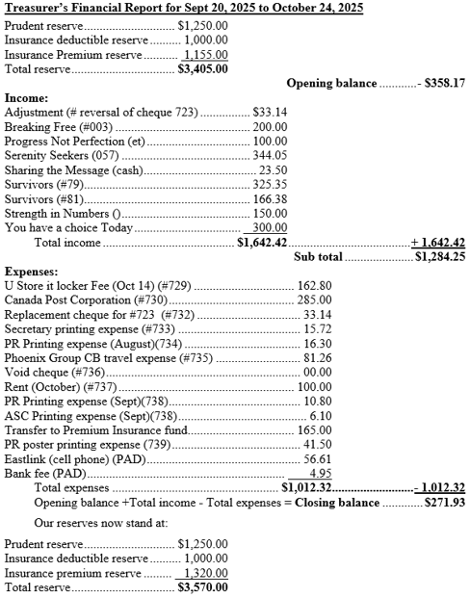

BREAK – 10 minutes
Attendance after break – numbers don’t change

OLD BUSINESS:
Open Positions:
Area Chair – Vadim & Jennifer. Majority vote: in favor of Jennifer M. Jennifer is voted in by ballot for the position of Chair

Area Vice Chair – Leigh stepped down at October Area. No more nominations or volunteers

Activities Chair – No nominations or volunteers

Archives Chair – Dave B voted in

Literature Chair – No nominations or volunteers

PR Chair – Aubrey voted in

Alternate Secretary – Tyler F volunteered. Not a majority for clean time waiving. As there will not be anyone in the Secretary position, Tyler is not comfortable with being voted in as Alternate. In favor of waiving clean time 6 groups. We do not have 2/3rds so Tyler will not be voted in

Secretary – JuleeAnn stepped down by email during the month of October from election for another term as Secretary. JuleeAnn was appointed to fill the role of Secretary for the November Area meeting. Noelle volunteered and qualified. Take back to home groups.

Regional Committee Member (RCM) – Paula R nominated. Paula accepted and qualified. Paula has had the position of RCM in the past (approx. 10 years). Region is online on November 9th and Paula will be there. Up to Chair to appoint Paula for next month. Paul appointed. Take back to home groups.

Alternate RCM – No nominations or volunteers

Alternate Treasurer – Kathleen M. 11 groups voted in favor. Current outgoing Treasurer (Jennifer), as Area Chair will mentor Kathleen

Treasurer – No nominations or volunteers

OPEN FORUM:
Dolores F – spoke on her personal feelings about previous months Area meeting
Ray K – hybrid meetings, feel they are really important. More people involved and doesn’t take much to do it. Perhaps look for a different place as there is no wifi. Feels hybrid meetings are worth a try.
Darrell P – keeping the meeting list updated. They went to a meeting that said on the list that it was wheelchair accessible, and it was not
Dave B – GSRs, when you are writing in anniversaries please add meeting date not clean date
Paula – how does this Area hold people accountable for their service positions? One of the reasons she came was that the RCM has not been involved since prior to the GSR Assembly. One thing that we used to ask at this table was “have you fulfilled your previous positions”.
Jennifer – he has not fulfilled this part of his commitment but has fulfilled the Region portion of his commitment. The RCM did not receive mentorship.
Joanne – GSR position is super important. This is the group’s voice and that is what the GSR does. If we don’t have the GSRs carrying the voice of the groups, we are missing the point and not getting the voice of the fellowship. Perhaps hybrid is a good idea so more people could see what goes on at Area.
Bryne – I’m against having to have a year clean time to fill a position. We don’t know how many years that person may have had in the past. We bring back to home groups that we want people to volunteer for positions, but we turn them away because of not meeting a clean time requirement.
Em – supported Bryne. Feels we should consider less clean time for certain positions.
Chrissy – RCM may have gone to Region but he should be reporting this back toArea.
Clay – wee have the Service pamphlet “Guide to Local Groups”. Being as we are all involved in business meetings, perhaps I can send out the link to the Secretary to send out. Also provided the link.
Steve – clean time is “suggested”
Steve – prudent with NA funds and cost of printing opposed to the printer.

GROUP CONCERNS:
Leigh – to be more prompt with our starting time of 1:30pm Area meeting
Sharing the Message – the details of the printer to keep in mind for the future. See group report.

NEW BUSINESS:
Elections and Regional Assembly – November 9th Regional Assembly will be online. Paula R spoke: The CAR (Conference Agenda Report) will be up and coming. The questions will not be known until November for the next Regional Assembly. Do we want to do these questions as an Area in person (questions for February Regional Assembly) and make it fun? Perhaps renting a room? Perhaps ordering pizza for example. If we could talk a bit about it today – it will need to go back to groups but for today, would like an idea of if we would like to do this or not?
Explanation of groups votes for motions to be carried through to region. Feels it is a necessity to find a place to get together for the assembly and to discuss.

PROPOSALS:

Proposal #1 PR - $288.50 for poster

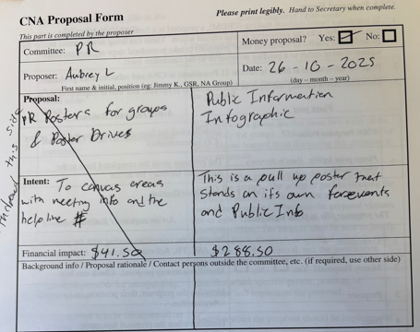

Question about if CB could book to use this also. Yes
If we are making one now, please use the most up-to-date information
Could CB put in a proposal to get their own? Yes
Could we use projectors instead of paying to update the information every time? PR Chair confirmed this information comes from NAWS. PR Chair also confirmed that we may not always be able to set up a projector where we need the image and it is convenient to have this one stop shop poster.
The cost to replace (which would be every 3 years). This type of poster is a valuable tool and would be used for professional types of commitments.
Julee to share the “banner” with the minutes
TAKE THIS BACK TO HOME GROUPS

Proposal #2 Area: Convention Committee Guidelines

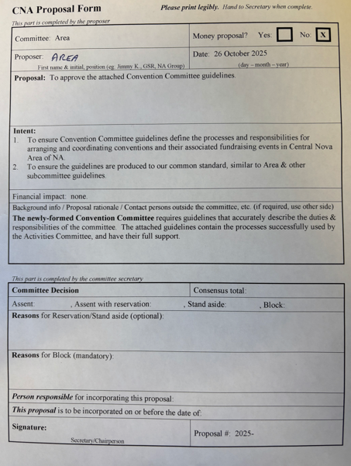

Meeting closed at 4:30pm. The next Area will November 30th 1:30pm, 322 Herring Cove Road

In loving service, JuleeAnn, Area Secretary
Email: secretarycnana@gmail.com

